🏆Darts Corner are seeking the ultimate darts champion: put your knowledge to the test and show who is the master 🏆

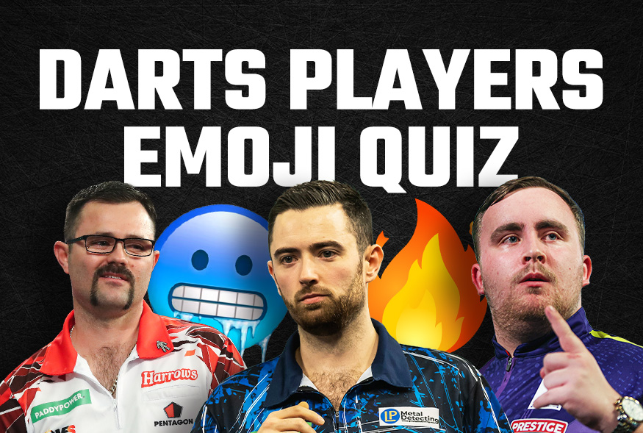
As darts fever continues to wash over the world, Darts Corner are looking for the ultimate champion to test their knowledge and guess who the 36 players are by the emojis, which represent what they are most famous for, in their ultimate darts pro emoji quiz.
Warning – this quiz is only for the truest of darts fans, so you’ll really need to know your stuff to get each answer right.
I’ve tried myself and struggled, you can checkout my review of the quiz here: Darts Quiz for Darts Corner.
Submit your answers to Darts Corner before the 12^{th of} April, and one lucky winner will be gifted a prize of a personalised darts board, as well as a £50 voucher.

